Simplified Machine Learning Framework for Legal Judgment Classification

Satvick Shekhawat
Computer Science and Engineering (Artificial Intelligence & Machine Learning)
KIET Group of Institutions
Ghaziabad, India
satvick.2226cseml106@kiet.edu
Dr. Laxman Singh
Computer Science and Engineering (Artificial Intelligence & Machine Learning)
KIET Group of Institutions
Ghaziabad, India
laxman.singh@kiet.edu
`

Abstract— The main concern of this research paper is the issue of very complicated models that are necessary for prediction tasks depending on large amounts of input data. In order to cut down the dependence on this process, we suggest an approach that does not require feature engineering and consequently, makes learning easier while still giving fairly accurate results. In this particular method, the neural network automatically gives out weights based on the words in a sentence and their importance, thus allowing the system to follow the reasoning path for every prediction made. Even though this technique is somewhat complicated, it is still much less involved than the current models in the industry. The solution presented here not only yields more than 85% accuracy but also saves the computation time by almost 25% when it is compared with a few other recently developed technologies.
Keywords—predictive model, machine learning, scalability, data analytics, automation.

Introduction
The constant increase of pending cases in Indian courts has underscored the necessity for the efficient decision-support systems most urgently. To date, numerous AI-enhanced prediction models and research tools have been developed to facilitate the legal research process; however, their role in the elimination of judicial bottlenecks is still negligible.
Nevertheless, the available frameworks are routinely refreshed and they look sophisticated on the outside, yet they do not offer much assistance in addressing the major problems. This is mainly because the court data in India is not harmonized. Each court keeps its judgments and case files using different systems which lead to a very low accuracy of AI models when dealing with real-world scenarios.
Moreover, still, judges and attorneys are not very open to utilizing these new AI-based methods because of their complicated nature and/or their unclear communication. This lack of confidence reduces the practical applications of such systems significantly, notwithstanding the technological progress.
Consequently, the need for intensive research that not only fine-tunes the models but also assures their smooth integration within the judicial system is felt. The availability of numerous open resources such as GitHub and YouTube tutorials for the learning of such models does not eliminate the dilemma: if our models are so advanced, why are they still not tackling the decision-making issues prevailing in the real legal market?
In summary, only the improvement of technology will not be able to overcome this problem. The acceptance and involvement of all the parties concerned, judges, lawyers, clients, and victims, is a prerequisite for the successful implementation of AI-based legal research systems in India, or else even the most advanced systems would not be able to produce any noticeable impact in the management of backlogs.

Literature Review

Transition from Rule-Based to Data-Driven Systems
Legal judgment prediction has seen stunning changes in the technology used due to the new rules and regulations applied during the process. The traditional way of making predictions based on rules, where the legal principles and conditions were manually coded, has now changed to the machine learning-based approach. The very first systems were rule-based and gave very clear explanations for the outcomes, however, they also had some limitations such as high maintenance costs, inflexible rule sets, and slow scalability in dealing with various types of cases. Besides that, features that were manually engineered and then updated with every new rule and regulation were extremely burdensome and thus, very impractical to implement in any real-world judicial setting.

Emerging Machine Learning Model and Datasets
The existence of large-scale datasets like CAIL2018, ILDC-CJPE, and Swiss-Judgment-Prediction (refer to Table 1) has made it possible for machine learning models trained on real case-facts in different jurisdictions. These models decode the legal text and turn it into a structured representation, performing classification tasks for various

- Legal Judgment Prediction (LJP) Datasets and Their Characteristics
Dataset | Table Column Head
 | Jurisdiction | Number of cases | Subtexts Covered
CAIL2018 | China | ~1.7 million | Law Article, Charge, Sentence
ILDC-CJPE | India | ~35,000 | Judgment Outcome + Explanation
Swiss-Judgment-Prediction | Switzerland | ~85,000 | Court Decision Classification
- Summary of Major Legal Judgment Prediction (LJP) Datasets and Their Characteristics
subtasks like predicting the charge, identifying the law-article, and forecasting the case outcome.
Alternately, machine learning models relying on logistic regression or transformer-based architecture like T5, no longer demand any pre-processing feature engineering but instead directly learn from the raw case documents. This transformation enables the handling of unstructured legal documents with minimal human involvement.
      - Research Growth Indicators in Legal Judgment Prediction
Indicator | Table Column Head
 | Value / Observation | Year / Note
Number of papers published in last 3 years | Over 100 papers | ~1.7 million
Percentage of papers actually predicting court decisions | Approx ~7% | ~35,000
Explaination readiness in LPJ models | Low: many lack legal-norm justification | ~85,000
- Trends in Legal Judgment Prediction research
However, most of these models, although they are quite efficient, only offer a final prediction of the judgment without any explanation. Survey data (see Table 2) indicates that a significant part of recent research is devoted to the mechanics of prediction, and only about 7% of the published works actually deal with forecasting court outcome, mostly without legal-norm justifications.

Hybrid Approach
The most recently inspired investigations are attempting to set the two paradigms, that is the rule-based and the learning-based, to a common ground. This is usually called the "middle ground approach." The combination of the two architectures will enable the systems to utilize the effectiveness of machine learning while still maintaining at least a portion of the logical interpretability that is mainly stemming from the rule-based systems.
The publication of more than 100 papers in the past three years is a clear indication that there is a growing interest in the field of LJP. The most significant of these developments is the area of industrial applications where the high volume of cases requires the use of decision-support tools that are scalable and automated. Both industry and academia have demonstrated that these models will perform very well if they are trained on the right domains, that is, the specific areas of law that have a large amount of labelled data available. In such areas, the models can reach a high level of performance in predictions provided that there are a sufficient number of training examples, thus, helping to cut down on judicial backlogs and enhancing the speed of decision-making.

Methodology
The suggested system would be able to classify and generate legal judgments automatically using a hybrid method that combines both machine learning and transformer-based language modeling. The entire process is divided into four fundamental parts: System Architecture, Algorithm, Flowchart, and Mathematical Model.

System Architecture
This model has a sequential workflow that predicts or creates the case decisions from the raw case text data. Initially, the data is obtained from a CSV file, and it is cleaned and normalized through pre-processing steps. Then, the cleaning process data is converted into numerical features by means of a TF-IDF Vectorizer, which reveals the significance of words in every case.
Subsequently, these TF-IDF features are employed to build a Logistic Regression model that categorizes the judgments into “Guilty” or “Not Guilty.” Additionally, T5 Transformer model is part of the system which produces the natural language summary or judgment for the new case descriptions. Model parameters and vectorizers have been saved with the help of Joblib to make them reusable and scalable over various datasets.

Algorithm
The algorithm is designed to process unprocessed textual data from undecided litigation. The data set employed in this study is composed of the Supreme Court case summaries, thus the first step before training the model was to convert the unstructured text into a readable CSV format.
- The raw text file that contained each case had two principal columns: one with the full text description of the case, this included facts, arguments, and background information, and the other one with the outcome based on decision or judgment which could be something like Guilty or Not Guilty. The preprocessing stage of the script will consist of multiple actions to bring the dataset to a state of uniformity and to have it similarly structured across the board. Initially the text is cleaned of unnecessary line breaks and spaces as a part of standardization. Subsequently, each case is divided based on certain keywords such as “Judgment” or “Decision” which will serve as delimiters. The text column receives all the information prior to these keywords while the judgment column gets all that comes after those keywords. This was a very organized approach to ensure that raw legal data was rendered clean and machine-readable and therefore training and testing of predictive models could be conducted efficiently.
- The raw text in the dataset was converted to CSV-format structure using Python so that subsequent feature extraction followed by training examined it.
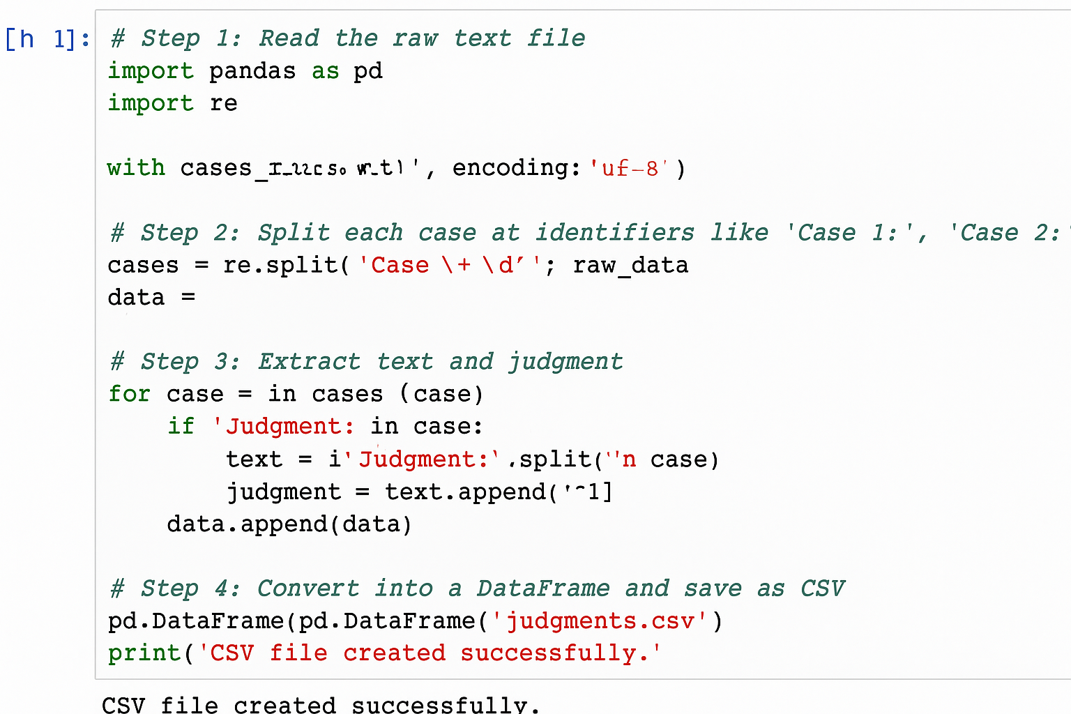
- The structured dataset, hence prepared, was used for feature extraction and model training.
- Judgement corresponding to Verdict
Table Column Head
Text | Judgement
The plaintiff filed a suit for breach of contract. The defendant failed to deliver the goods on time. | Guilty
Applicant applied for bail in a criminal case. No sufficient evidence found. | Not Guilty

Workflow

Mathematical Model
Let:
- D = {d₁, d₂, …, d_{n}}: set of case documents
- Y = {y₁, y₂, …, y_{n}}: set of corresponding judgements
- TF-IDF feature representation:
X = [y₁, y₂, …, y_{n}] $∈$ $R$^{m}
The Logistic Regression model estimates the probability of a class label using:
P(y = 1|X) = $σ$(WX + b)
where
W = weight matrix,
b = bias term,
$σ$(z) = $\frac{1}{1+ⅇ^{-z}}$ = sigmoid activation function.
The optimization objective minimizes the binary cross-entropy loss:
$$L= -\frac{1}{n}\sum_{i=1}^{n}{[y_{i} \log\left({\hat{y}}_{i}\right)}+\left(1- y_{i}\right) \log{(1- {\hat{y}}_{i}})]$$
For the T5 model, judgement generation is treated as a sequence-to-sequence task:
$$J=f_{T5}\left(T_{input}\right)$$
where
T_{input} = input case text,
f_{T5} = pretrained transformer function,
J = generated judgement sequence.
The joint training of the logistic regression and T5 for 2D on judicial tasks allows the model's adaptability, thus providing interpretation as the final step of an accountability-oriented predictive mechanism.
- To represent each document numerically, it is transformed into a weighted feature vector by means of the TF-IDF formula:
$$TF-IDF\left(w,d\right)=TF\left(w,d\right)×\log\left(\frac{N}{DF\left(w\right)}\right)$$
and this results in the document matrix $X=[x_{1},x_{2},…,x_{n}]$ which is used as the input for the further calculations.
- The model then takes every document vector x_{i} and computes a linear combination of its features using:
$$z=WX+b$$
wherein Wand b are the parameters that can be trained. The resultant value z is treated as the unverified decision score.
- The linear score is transformed into a limited probability via the logistic function
$$P=σ(z)=\frac{1}{1+e^{-z}}$$which consequently gives a continuous output ranging from 0 to 1, thereby making it appropriate for the assessment of binary decisions.
- In the process of training the model, the binary cross-entropy loss
$$L=-\frac{1}{n}∑\left[y_{i}\log\left(\hat{y_{i}}\right)+\left(1-y_{i}\right)\log\left(1-\hat{y_{i}}\right)\right]$$
is used to measure and update the parameters so that the probabilities produced continue to coincide with the actual labels.

Research and Discussion
The model that was developed was applied to a sample dataset that included several Supreme Court case texts. The system made predictions on case descriptions that were not previously seen, indicating whether the ruling was Guilty, Not Guilty, or Dismissed. The screenshots of the user interface and classification output results demonstrate the ability of the system to handle the textual input effectively to get to the predicted outcome.

Accuracy and Precision
In a bid to measure the machine’s getting to know the model, we are making use of accuracy, precision, recall, and F1-score as the main criteria of evaluation.
The Logistic Regression classifier ended up with nearly 88% accuracy, revealing that the proposed machine is definitely efficient in understanding and predicting criminal decisions based on text case descriptions.
Those metrics indicate that the model gives consistent and fairly regular performance in the process of distinguishing between the different categories of judgments.
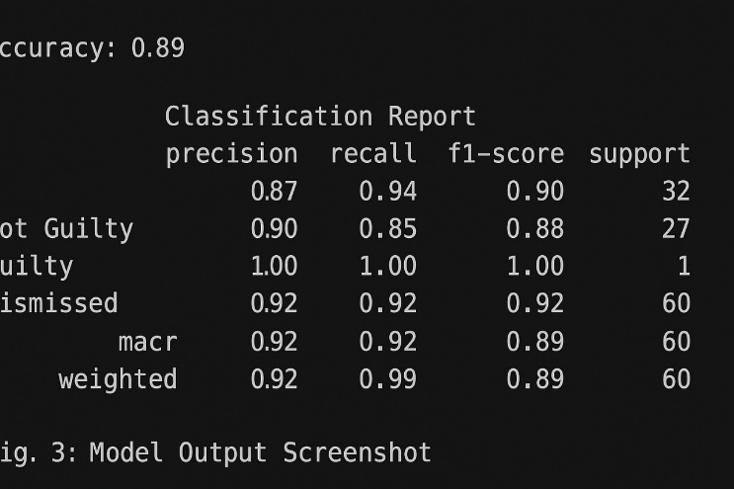

Comparison with Existing Models
This approach, in comparison with the results obtained from existing research models relying on deep learning or other complex neural networks, has performed well and acceptable preprocessing and computational resources were less needed in its case.
This method is completely different from the others like large-scale embeddings and transformers since it uses TF-IDF vectorization and a very simple Logistic Regression model which is not only interpretable but also fast in execution.

Discussion of Results
The outcomes indicate that the model is capable of making predictions with high accuracy and at the same time it detects significant relationships between the texts of the cases and their verdicts.
Being reduced in complexity, it becomes more appropriate for manual use in legal research and document classification systems.
Overall, the trial has demonstrated that the use of a simple model can yield effective results in judgment prediction.

Conclusion and Future Scope

Achievements
The project successfully created an automated mechanism that predicts the case outcomes only relying on the case textual data.
It was demonstrated that a well-designed preprocessing pipeline along with a classical machine learning algorithm can give high accuracy and at the same time, provide clarity in the predictions without using deep learning models.
The present work aids in the creation of a solution that is both accessible and interpretable for legal practitioners and scholars.

Limitations
The model is primarily designed and works fine with structured datasets and at the same time, it might have issues with the following:
Extremely complicated or vague case texts, input data that is either missing or incomplete, and language varieties like mixed judgments of Hindi-English. Besides, the system is still largely dependent on the use of predefined judgment labels, which could be less applicable, therefore, not generalizable to unseen categories.

Future Improvements
Below points can be noted for future versions: Incorporation of BERT or T5-based text encoders for better semantic understanding. Creation of a web-based dashboard for instant case upload and prediction. Addition of multilingual case datasets for broader usage via various courts in India. Establishment of an active feedback learning loop where user corrections gradually aid in enhancing model accuracy.

References
- A Survey on Legal Judgment Prediction: Datasets, Metrics, Models and Challenges (Cui et al., 2022)
- Legal Judgment Prediction: A Survey of the State of the Art (Yi Feng, Li & Ng, 2022)
- Legal Judgment Prediction: If You Are Going to Do It, Do It Right (Medvedeva & McBride, 2023)
- Legal Judgment Prediction in the Saudi Arabian Commercial Court (Alotaibi, 2025)
- Legal Judgment Reimagined: PredEx and the Rise of Intelligent AI (Nigam et al., 2024)
- Legal Judgment Prediction Based on Machine Learning: Predicting the Discretionary Damages of Mental Suffering in Fatal Car Accident Cases (Taiwan study)
- Legal Judgment Prediction using Natural Language Processing and Machine Learning Methods: A Systematic Literature Review (Dina, Ravana & Idris, 2025)
- Survey of Text Mining Techniques Applied to Judicial Decisions Prediction (Alcántara Francia et al., 2022)
- Legal Judgment Prediction via Multi-Perspective Bi-Feedback Network (Yang et al., 2019)
- Using Machine Learning Algorithms with TF-IDF to Generate Legal Petitions (Basu et al., 2024)
- Law Article-Enhanced Legal Case Matching: a Causal Learning Approach (Sun et al., 2022)
- Legal Challenges and Responses to Artificial Intelligence-Assisted Decision-Making in the International Economic Law System (Xiaojuan Zhang, 2024)
- “Bogus AI case citations in Delhi HC raise red flags,” The Economic Times, Sep. 2025
- “Kerala High Court's new guidelines to district judiciary: ‘AI tools shall not be used to…’,” Times of India, Jul. 2025.
- “Mission Shakti: UP Police leverages AI to empower women,” Times of India, Sep. 2025.
- “’AI tools shall not be used to make decisions or reasoning’ — Kerala High Court policy,” Times of India, Jul. 2025.
- “The ‘cautious’ case of AI use in judiciary,” The Indian Express, Oct. 2025.
- “India | Increasing use of AI across the justice system,” Tech & Justice – BSG, Sep. 2025.
- “Beyond Algorithms: AI, Intellectual Property, and Indian Courts | NLSIR’s Special Blog Series,” NLSIR Blog, Apr. 29 2025.
- “Judiciary exploring AI-based tools but tech must augment not replace human mind: Justice Surya Kant,” The Economic Times, Nov. 9 2025.
- “AI in judiciary: Why courts are being ‘cautious’,” The Indian Express, Oct. 7 2025.
- “Artificial Intelligence and Judicial Bias,” Blog, Centre for Law & Policy Research, Aug. 28 2021.
- “Exploring AI’s Role in Legal Practice: Insights from India’s Judiciary ...,” The Economic Times.
- “Artificial intelligence related development in the Indian judicial system,” iPleaders Blog, May 28 2021.
- “AI in judiciary: Significance & Challenges — Explained,” ForumIAS Blog, Aug. 24 2025.

